**Requirements**

**A. Plain English description**

We were contacted by Mr. Alfred Martinez to create an app for his concept The Battle for Dental Perfection. His goal is to provide a created universe where the characters he created uphold good dental practices, morals, and general wellbeing. He started with a loose concept in mind for the app that was only his characters with a biography. After collaborating, we have settled on a more robust app for Android initially to use his concepts.

This app will include a multitude of functions. The first one being a brushing reminder that will notify the user to go brush their teeth based on pop up notifications that occur at user-specified times. Next, there will be a character biography screen that will display his created characters while supplying their name, biography, and dental issue/aid that they represent. Also, a timer with an animation will be included to aid the user by providing a visual cue as to how to brush properly and a clock to ensure they brush for the recommended amount of time. Additionally, a short story outlining the main characters and non-centric characters dealing with real life issues and dental problems. Finally, a game will be included that takes inspiration from Flappy Birds while adding additional difficulty and inserts dental related art and themes. In between each section there will be a false loading screen that will display factoids about dental care and hygiene. All these sections will be accessible through a main hub screen.

The hub screen will consist of the Battle for Dental Perfection logo, the five buttons to lead to the 5 different sections, and an options menu to change between English and Spanish text for the app.

The brushing reminder section will include two windows. The first window displays the two currently selected times. Next to each time, there will be a change button that will take the user to a time changer so they can modify the alarm to fit their schedule.

The character biographies screen will act as if each character is a card. The unflipped side shows the character in full with their name at the bottom. On tapping the card, it will flip and show a more detailed description of the character. These details include their full title and name, biography, and what they represent within the universe. A few cards will be accessible initially, the rest are earned by using the brushing timer over a long period of time. This is to ensure people keep coming back to the app.

The brushing animation and timer will consist of a background picture of teeth that start yellowed but become whiter as the two minute timer counts down on the user’s activation. While the timer runs, a brush will be performing circular motions along the teeth to reinforce the proper way to brush. On completion, the user is given a “credit”. On reaching a certain number of credits, the user can use these to unlock a character biography card. This acts as an incentive to keep using the app. This animation can be played as many times as a user wishes, but credit will only be given twice a day. This is to prevent cheating of the system to unlock content without doing the activity.

The short story will involve characters within the universe, both the heroes and villains and normal civilians. The story will be told through panels that the user interacts with. Each panel will have a good and bad choice to be made. These choices will involve both dental related issues but also moral issues. At the end of the story, a tally will be made of the ratio between good and bad choices. Depending on the outcome, an end screen will summarize the user’s performance.

The game will mimic Flappy Birds in that it is simple but challenging; easy to learn but hard to master. We chose to imitate this game since it became wildly popular to people of all age groups. Mr. Martinez wishes his app to be used by as many people as possible, so having a game of this nature will draw people in. The base Flappy Birds game had a bird that traveled in a descending arc at all times. On tapping the bird, it shot upwards in an arc slightly then resumed dropping. By timing these taps, the user had to navigate a set of randomly generated obstacles. We are modifying this concept by adding difficulty levels and new art assets. When navigating to the game from the hub, a main menu will be shown. This screen will show the user’s high score, the difficulty setting, and a button to start the game. Instead of a bird, the player will control a tooth that starts out pristine. The user will also have an amount of errors they can make before the game ends (“hit points: HP”). As the tooth loses HP from hitting obstacles (junk foods) it will begin to decay. The user can restore HP by causing the tooth to run into dental related icons placed randomly in the game or “good” food up to a point. Good food will restore 1 HP after X amount are gathered, but going over this will cause HP loss due to natural sugars, acid, etc.. The game will scroll left to right at a steady pace. The difficulty settings will alter the amount of HP the user starts with. As the level progresses, the obstacles come more swiftly. The goal is to make a high score.

**B. Functional vs. Non-Functional**

**Functional**

From the main menu, the user will be taken to one of the five main sections within the app. From here, each section will provide some kind of aid, stimulation, or education on proper dental care. The timer section will use notifications to alert the user of brushing times, as well as let the user change these times. The story section will take the user though a story by using button taps to progress the story. The brushing animation will provide a set time for the user to follow as well as provide a visual on how to brush properly. The biography section will give details on the characters and provide some animations. Finally, the game will provide a reason to keep opening the app through its challenge and easy play style.

**Non-Functional**

Majority of the app is focused on UI elements and manipulation, so we will ensure that performance does not drop across the app. Most of this app is aimed at children and their parents to reinforce brushing habits at a young age, though anyone is free to use all parts of the app. The game is meant to keep people coming back to the app even if they don’t need to brush at the moment. Even if the game is the only section opened by the user, they will still receive dental health information through the loading screens we will put in.

**C. Structured**

1. The mobile application should allow the user to set the time of the two brushing reminders
   1. The reminders can be set at any time from 12a.m. to 11:59 p.m.
   2. Each reminder will make a notification pop up on the phone
   3. Once the notification is checked, the app should direct to the brushing timer
2. The mobile application should allow the user to access the brushing timer
   1. The timer will begin at 2 minutes and count down
      1. The user will press the start button and the timer will start
   2. The timer will display a set of teeth that will start yellow and become progressively white
   3. The timer will lock the start button after each use for 8 hours
3. The mobile application should allow the user to change the language of the app from English to Spanish and from Spanish to English
4. The mobile application should allow the user to open the character bios
   1. The character bios will be split into their own sections
      1. Each section will be intractable and will flip over to show the full character bio
5. The mobile application should allow the user to open the flappy game
   1. The game will have 3 difficulty settings
      1. User can select easy, medium, or, hard
   2. After the user presses start, they will need to tap the screen to begin
      1. Each tap thereafter will keep the player afloat
   3. The user must avoid all junk food objects
      1. If the user touches a junk food object they will lose health
         1. Easy mode will reduce 10-20% health
         2. Medium mode will reduce 30-40% health
         3. Hard mode will reduce 50% health]
   4. The user can try to grab power-ups
      1. If the user grabs certain power-ups they will regain health
         1. Easy mode
            1. Toothbrush
            2. Mouthwash
            3. Floss
         2. Medium mode
            1. Toothbrush
            2. Mouthwash
            3. Floss
         3. Hard Mode
            1. Toothbrush
            2. Mouthwash
            3. Floss
   5. The user can grab good foods, but only so many before they become a hindrance
   6. The object is to get a high score
   7. The user will be able to write their initials as high scores
6. The mobile application should allow the user open the Karma game
   1. Once started the user can select two choices for each slide
      1. One choice will give the player good karma
      2. The other choice will give the player bad Karma
   2. Once the game is over there will be an ending
      1. More good Karma will play the good ending.
      2. More bad Karma will play the bad ending.

**D. Diagrams**

**Flowchart**

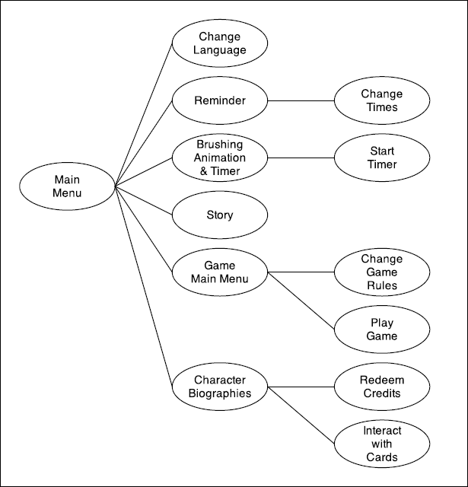

**Notes on visualization**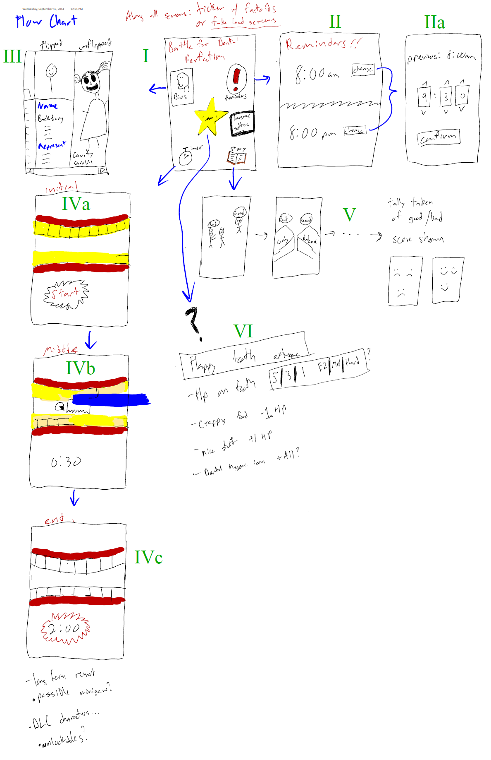

**Analysis**

When we first met with Alfred, his idea for an application was very broad and simple. He more or less wanted a simple character bio screen and an animation showing someone how to brush their teeth. During the first meeting, we decided that we were going to bulk up the project a bit, and add a few more components to it. In the end we decided that we were going to have a total of 5 components in the application.

The first thing we agreed to add was a main screen. This would basically act as a hub to get everywhere within the program. We also, while trying to figure out what would be on the main screen, suggested that since his comic and the magazine his comic would be in was bilingual that there should be a button to change the languages.

When we first sat down the main thing that Alfred wanted was a reminder for kids to brush their teeth. After finishing up the main screen, we came back to that idea. Alfred suggested two times that would be adjustable and we agreed that it could easily be done.

After those two, we came to his original idea of the character bios. We let Alfred come up with the entire idea for this one. He told us exactly what he wanted out of the biographies and we told him what could be done and what couldn’t be done. We decided on simple card based biographies that would flip over showing either the background of the character or the entire character itself.

After the bio there was nothing else that Alfred had in mind, so we had to beef up the program a little bit. We decided that one of the things that we should add is a timer for kids to know how long they should brush their teeth. We then realized we needed to add more re-playability. We pitched an idea of having the user earn credits of sorts to unlock more characters in the biographies. This would keep the users coming back to the app.

We then decided that if there was going to be any reusability in the app that there would need to be games. We came up with two games and pitched them to Alfred. The first being a story-karma type game. We gave Alfred the basic gist of the game. It would have a good and a bad choice and each one you picked would work towards a different ending. We made sure that we did not cross any lines with the moral choices we might use.

Before coming up with the second game, we agreed that the project still had very little re-playability. So we decided to add a game inspired by Flappy Birds. On this piece of the program everyone added an idea of their own. To make sure that it was going to be able to be completed, we only wrote down the necessary things that would make the game fun.

Alfred also stated that he wanted there to be some sort of education within the app and all the games. For this we came up with fake loading screens. These “loading screens” would show a small factoid about dental health. We came up with at least 20 ideas to put into each screen.

**Design Diagrams**

**Block diagram**

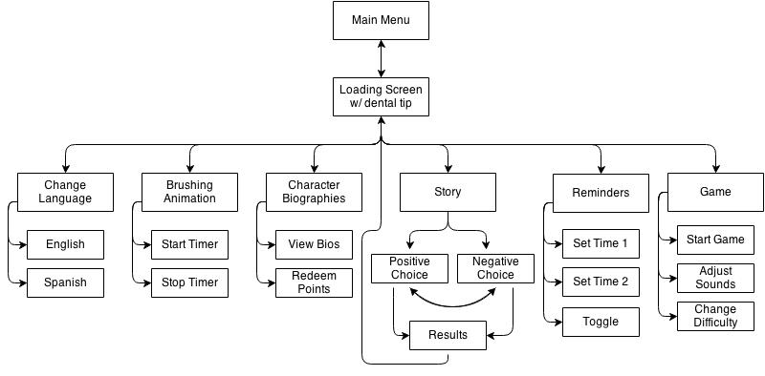

**Use Cases**

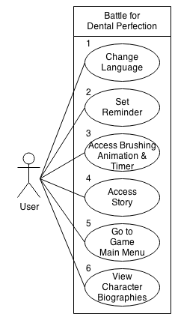

**Use case ID: 1**

Use case name: Change language

Summary of use case:

The user can go to the screen to change the language of the program.

Actors: User

Preconditions:

The user has loaded up the application and they are on the main screen.

Successful scenario:

The user is then taken to the screen that will allow them to change the language options.

Alternative scenario:

The touch is not recognized and nothing happens.

The page fails to load and the user is sent back to the main screen.

The app freezes and the program closes.

Post conditions:

The user is now on the change language screen.

**Use case ID: 2**

Use case name: Set Reminder

Summary of use case:

The user can go to the set reminders page.

Actors: User

Preconditions:

The user has loaded up the application and they are in the main menu.

Successful scenario:

The user has been taken to the set reminders page.

Alternative scenario:

The program freezes and the app closes.

The function is not found and the program goes back to the main menu.

The touch is not recognized and nothing happens.

Post conditions:

The user is now in the set reminder page.

**Use case ID: 3**

Use case name: Access animation and brushing timer

Summary of use case:

The user can go to the animation and brushing timer page.

Actors: User

Preconditions:

The user has loaded up the application and they are in the main menu.

Successful scenario:

The user has been taken to the animation and brushing timer page.

Alternative scenario:

The program freezes and the application closes.

The function is not found and the program goes back to the main menu.

The touch is not recognized and nothing happens.

Post conditions:

The user is now in the animation and brushing timer.

**Use case ID: 4**

Use case name: Access Story

Summary of use case:

The user can go to the story main menu.

Actors: User

Preconditions:

The user has loaded up the application and they are in the main menu.

Successful scenario:

The user has been taken to the story main menu page.

Alternative scenario:

The program freezes and the application closes.

The function is not found and the program goes back to the main menu.

The touch is not recognized and nothing happens.

Post conditions:

The user is now in the story main menu.

**Use case ID: 5**

Use case name: Go to game main menu

Summary of use case:

The user can go to the game main menu.

Actors: User

Preconditions:

The user has loaded up the application and they are in the main menu.

Successful scenario:

The user has been taken to the game main menu page.

Alternative scenario:

The program freezes and the application closes.

The function is not found and the program goes back to the main menu.

The touch is not recognized and nothing happens.

Post conditions:

The user is now in the game main menu.

**Use case ID: 6**

Use case name: View character Biographies

Summary of use case:

The user can go to the character Biographies page.

Actors: User

Preconditions:

The user is in the main menu.

Successful scenario:

The user is taken to the character biographies page.

Alternative scenario:

The program freezes and the application closes.

The function is not found and the program goes back to the game main menu.

The touch is not recognized and nothing happens.

Post conditions:

The user is now in the character biographies page.

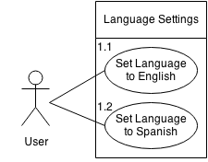

**Use case ID: 1.1**

Use case name: Set language to English

Summary of use case:

The user can change the language of the program to English.

Actors: User

Preconditions:

The user has loaded up the application and they in the change language settings.

Successful scenario:

The language of the program will set to English.

Alternative scenario:

The program is already in English and nothing happens.

The function is not found and the program stays in the previous language.

The touch is not recognized and nothing happens.

Post conditions:

The language of the program is now set to English and the user exits back to the main menu.

**Use case ID: 1.2**

Use case name: Set language to Spanish

Summary of use case:

The user can change the language of the program to Spanish.

Actors: User

Preconditions:

The user has loaded up the application and they in the change language settings.

Successful scenario:

The language of the program will set to Spanish.

Alternative scenario:

The program is already in Spanish and nothing happens.

The function is not found and the program stays in the previous language.

The touch is not recognized and nothing happens.

Post conditions:

The language of the program is now set to Spanish and the user exits back to the main menu.

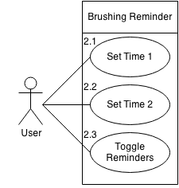

**Use case ID: 2.1**

Use case name: Set Time one

Summary of use case:

The user can set the first time to remind him to brush his teeth.

Actors: User

Preconditions:

The user has clicked the set reminder button from the main menu and is now on the set reminder page.

Successful scenario:

The first reminder time has been set and notifies the user of the change. The program changes the first time to the user’s specific time

Alternative scenario:

The change time function is not found and the time doesn’t change.

The touch is not recognized for the change time 1 button and the time does not come up.

The touch is not recognized for the time selection and the time is continued to be displayed.

Post conditions:

The time has been selected and the user has been notified of the change and the user is back on the set reminder page.

**Use case ID: 2.2**

Use case name: Set Time two

Summary of use case:

The user can set the second time to remind him to brush his teeth.

Actors: User

Preconditions:

The user has clicked the set reminder button from the main menu and is now on the set reminder page.

Successful scenario:

The second reminder time has been set and notifies the user of the change. The program changes the second time to the user’s specific time

Alternative scenario:

The change time function is not found and the time doesn’t change.

The touch is not recognized for the change time 2 button and the time does not come up.

The touch is not recognized for the time selection and the time is continued to be displayed.

The time is the same as the first time and does not set.

Post conditions:

The time has been selected and the user has been notified of the change and the user is back on the set reminder page.

**Use case ID: 2.3**

Use case name: Toggle reminders

Summary of use case:

The user can set to have the reminders either on or off.

Actors: User

Preconditions:

The user has clicked the set reminder button from the main menu and is now on the set reminder page.

Successful scenario:

If the toggle button is set to on, the user clicks the button and the reminders are turned off.

If the toggle button is set to off, the user clicks the button and the reminders are turned on.

Alternative scenario:

The touch is not recognized and nothing happens.

The function is not found and nothing happens

Post conditions:

The button has been pressed and either the reminders have been set to on or off and the user remains on the set reminders page.

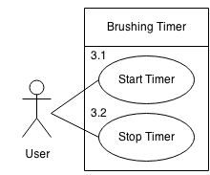

**Use case ID: 3.1**

Use case name: Start timer

Summary of use case:

The user can start the timer which will start the animation.

Actors: User

Preconditions:

The user pressed the brushing timer and animation button and is now on the page.

Successful scenario:

The button was pressed and the timer and animation are now going.

Alternative scenario:

The timer fails to start.

The animation fails to start.

The touch is not recognized and nothing happens.

Post conditions:

The timer and animation are now going and at 2 minutes the timer and animation will stop.

**Use case ID: 3.2**

Use case name: Stop timer

Summary of use case:

The user can stop the timer which will stop the animation.

Actors: User

Preconditions:

The user pressed the start timer button and the animation and timer are going.

Successful scenario:

The button was pressed and the timer and animation are now stopped.

Alternative scenario:

The timer fails to stop.

The animation fails to stop.

The timer was already stopped so nothing happens.

The touch is not recognized and nothing happens.

Post conditions:

The timer and animation are now stopped and the user is on the brushing and animation page.

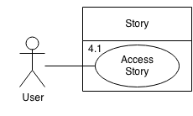

**STORY NOT INCLUDED IN THIS VERSION DUE TO LACK OF MATERIALS**

**Use case ID: 4.1**

Use case name: Access Story

Summary of use case:

The user can start the story game.

Actors: User

Preconditions:

The user is in the story main menu and presses the start story button.

Successful scenario:

The user has started the story.

Alternative scenario:

The program freezes and the application closes.

The function is not found and the program stays in the story main menu.

The touch is not recognized and nothing happens.

Post conditions:

The user is now playing the story game.

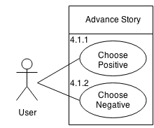

**Use case ID: 4.1.1**

Use case name: Choose positive.

Summary of use case:

The user can choose the positive choice of the story.

Actors: User

Preconditions:

The user is playing the story game.

Successful scenario:

The user has chosen the positive story choice.

Alternative scenario:

The function is not found and nothing happens.

The touch is not recognized and nothing happens.

Post conditions:

The user has chosen the positive choice, the points have been added to the total, and the next screen is shown. If it is the final screen, based on the amount of points, the ending is shown.

**Use case ID: 4.1.2**

Use case name: Choose Negative.

Summary of use case:

The user can choose the negative choice of the story.

Actors: User

Preconditions:

The user is playing the story game.

Successful scenario:

The user has chosen the negative story choice.

Alternative scenario:

The function is not found and nothing happens.

The touch is not recognized and nothing happens.

Post conditions:

The user has chosen the negative choice, the points have been added to the total, and the next screen is shown. If it is the final screen, based on the amount of points, the ending is shown.

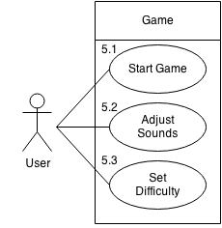

**Use case ID: 5.1**

Use case name: Start game

Summary of use case:

The user can start the game.

Actors: User

Preconditions:

The user is in the game main menu.

Successful scenario:

The game loads up and the user can start playing.

Alternative scenario:

The program freezes and the application closes.

The function is not found and the program goes back to the game main menu.

The touch is not recognized and nothing happens.

Post conditions:

The user is now playing the game.

**Use case ID: 5.2**

Use case name: Adjust sounds

Summary of use case:

The user can toggle the sound on or off.

Actors: User

Preconditions:

The user is in the game main menu.

Successful scenario:

If the sound is toggled on, then the sound will be set to off.

If the sound is toggled off, then the sound will be set on.

Alternative scenario:

The function is not found and the program goes back to the game main menu.

The touch is not recognized and nothing happens.

Post conditions:

The sound has been set to on or off and the user is still on the game main menu

**Use case ID: 5.3**

Use case name: Set difficulty

Summary of use case:

The user can set the difficulty to easy, medium or hard.

Actors: User

Preconditions:

The user is in the game main menu.

Successful scenario:

If the game is set to easy, then the difficulty will change to medium.

If the game is set to medium, then the difficulty will change to hard.

If the game is set to hard, them the difficulty will change to easy.

Alternative scenario:

The function is not found and the program goes back to the game main menu.

The touch is not recognized and nothing happens.

Post conditions:

The difficulty has been set and the user is still on the game main menu.

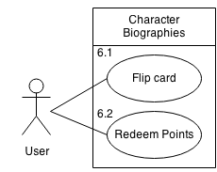

**Use case ID: 6.1**

Use case name: Flip card

Summary of use case:

The user flip the character card to either show the full bio or the full character

Actors: User

Preconditions:

The user is in the character biographies page.

Successful scenario:

If the card is showing the full bio, then the card will flip to show the full character.

If the card is showing the full character, then the card will flip to show the full bio.

Alternative scenario:

The program freezes and the application closes.

The function is not found and the program does nothing.

The touch is not recognized and nothing happens.

Post conditions:

The card is now flipped to show an opposite side.

**Use case ID: 6.2**

Use case name: redeem points

Summary of use case:

The user can redeem points to unlock characters.

Actors: User

Preconditions:

The user is in the character biographies page

Successful scenario:

The user redeems his points to unlock the next character.

Alternative scenario:

The user does not have enough credits, in which the program notifies the user.

The function is not found and the program goes back to the game main menu.

The touch is not recognized and nothing happens.

Post conditions:

The user has either redeemed his points or has been notified that he has not earned enough credits.

**Class Diagrams**

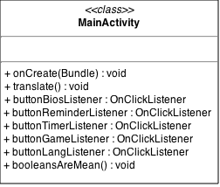

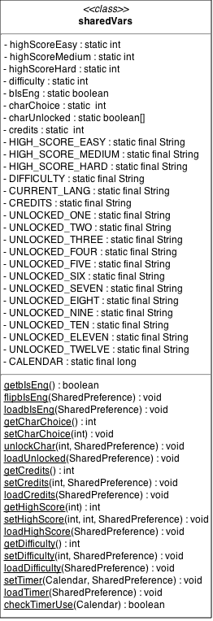

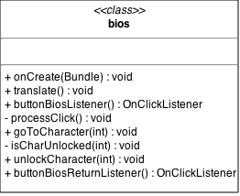

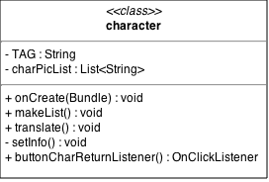

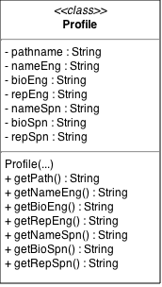

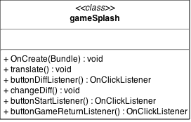

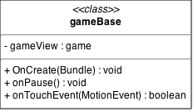

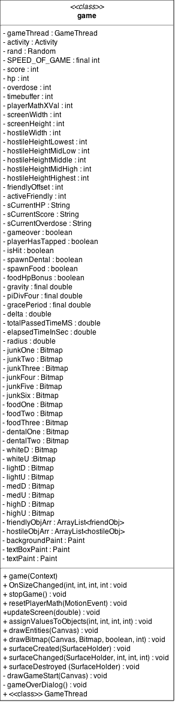

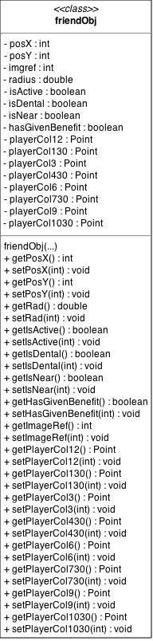

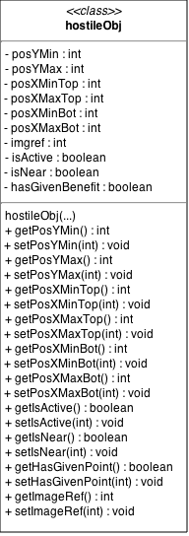

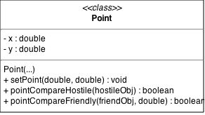

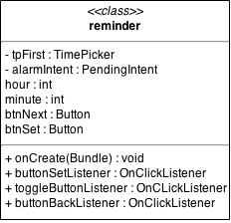

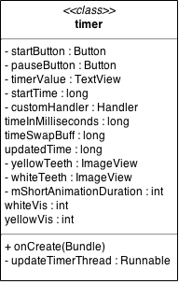

**Sequence Diagrams**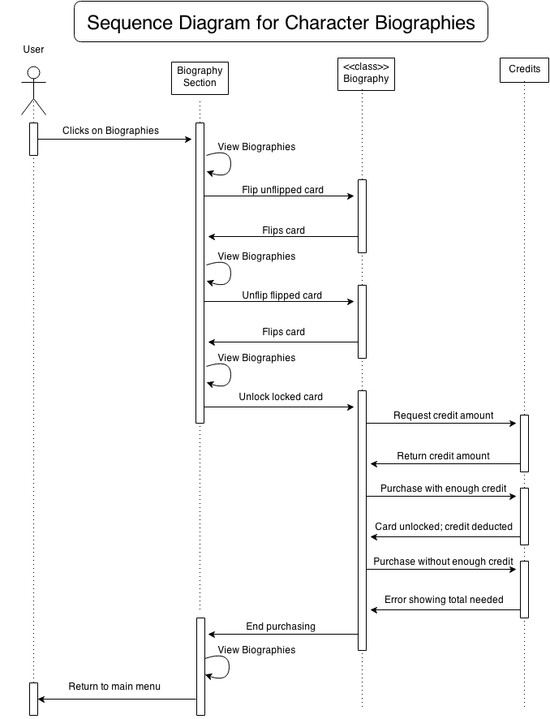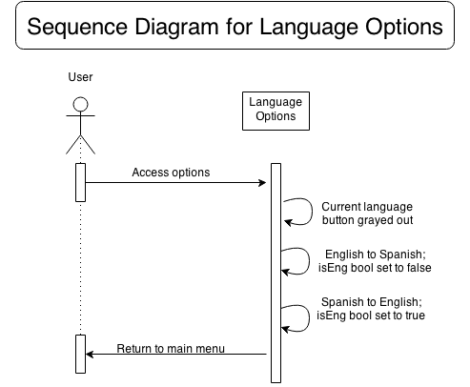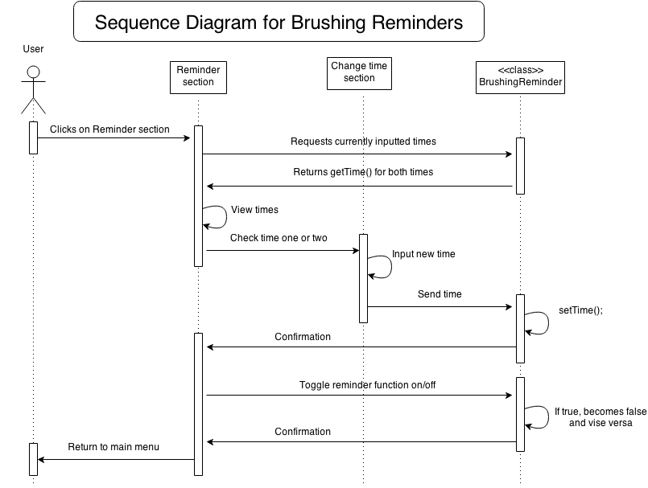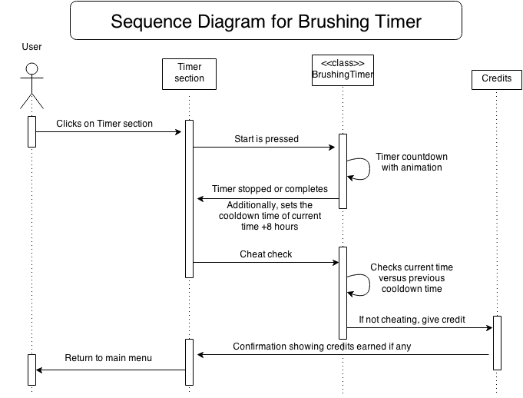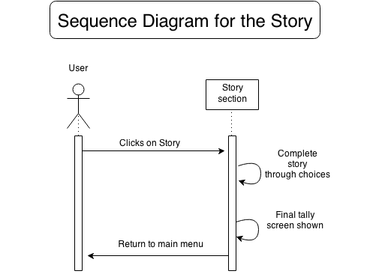

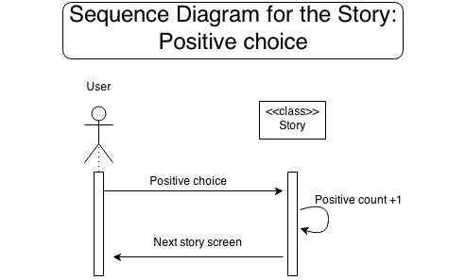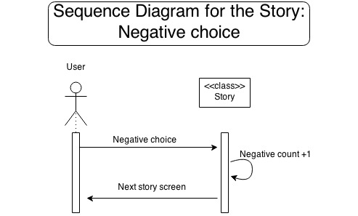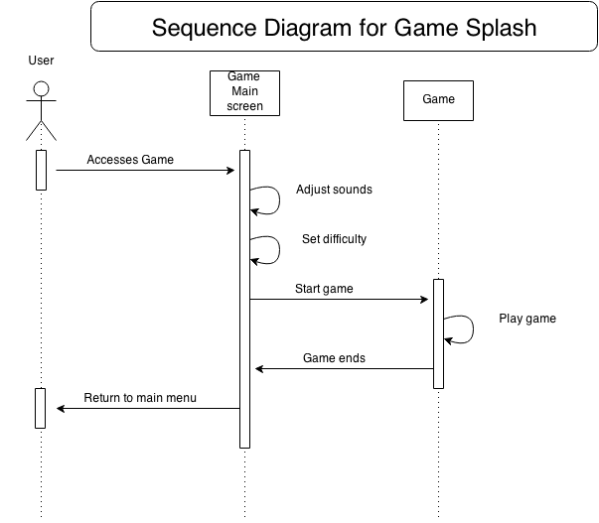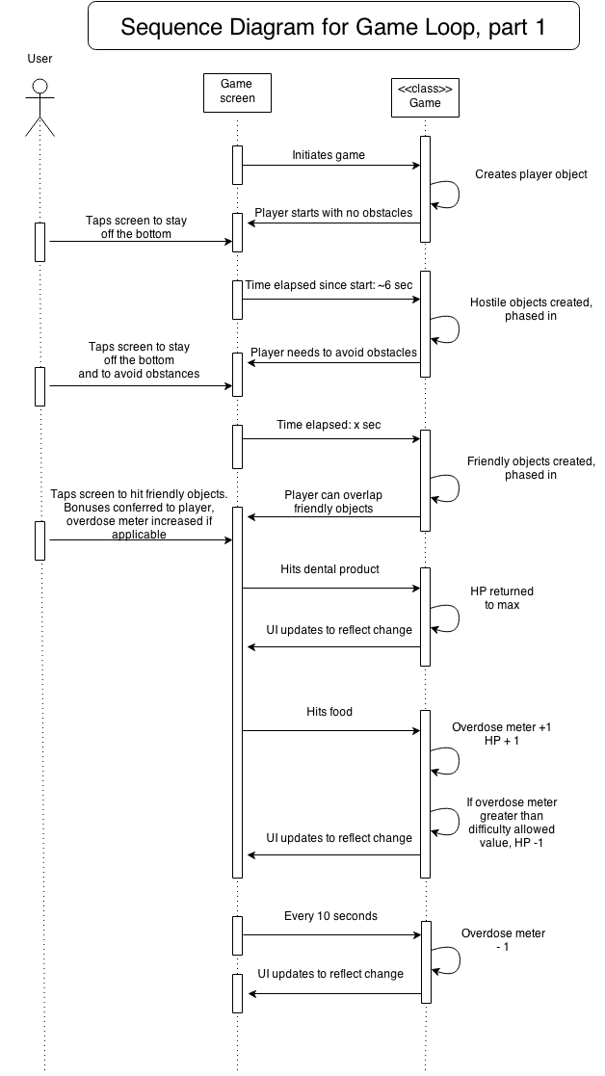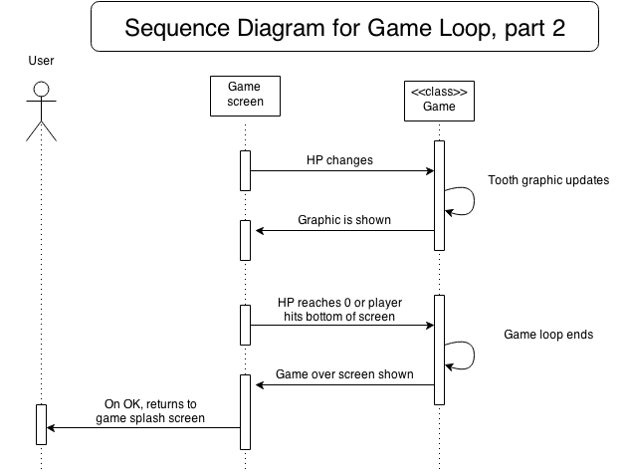

**Manual**

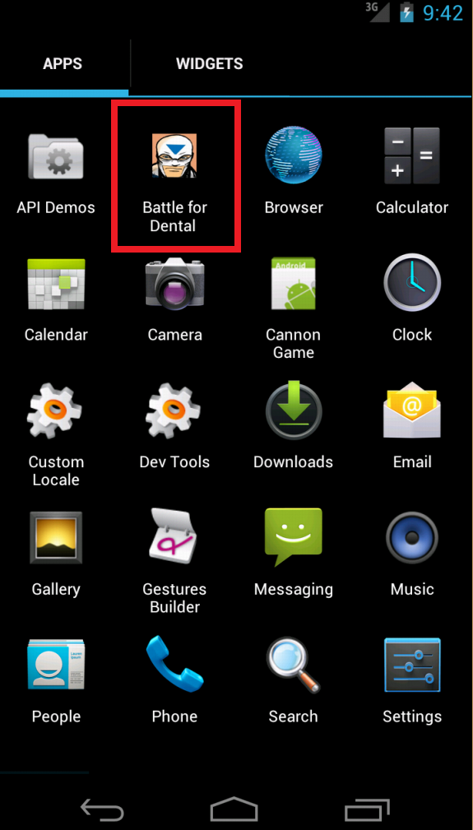

Icon on phone dashboard that will launch the app.

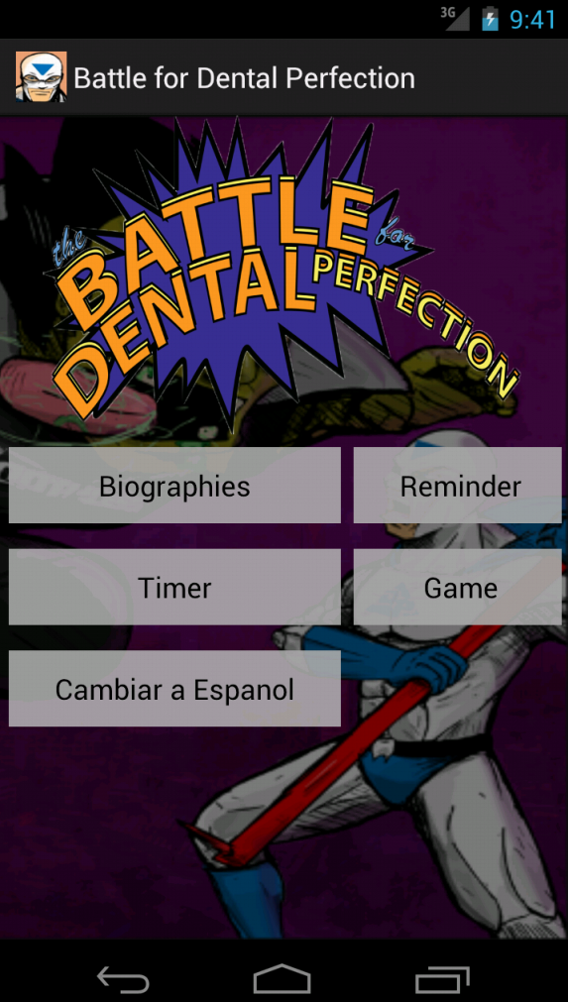

Main screen. Buttons will take you to the respective sections.

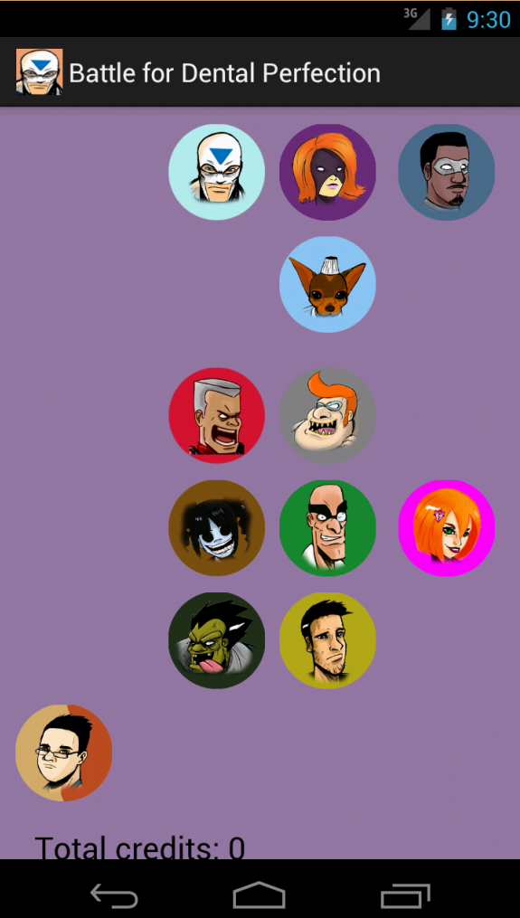

Biographies part 1.

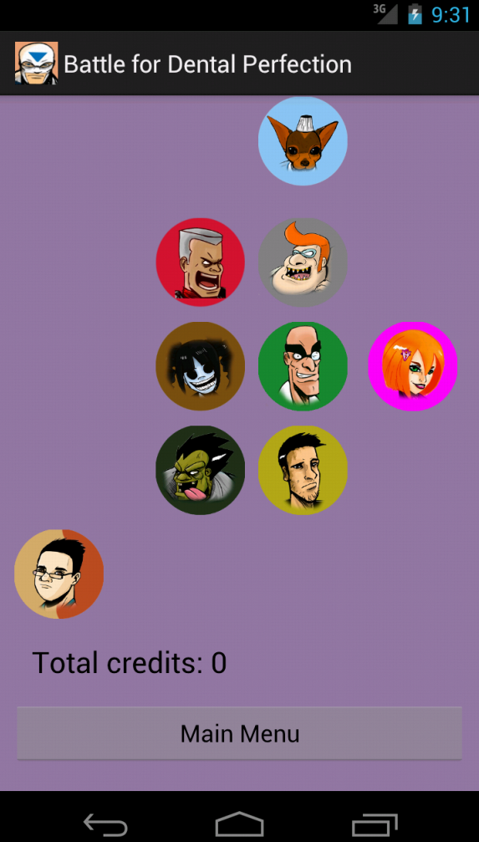

Biographies part 2.

Displays all characters. Clicking on a characters head will take you to their biography. Dental Perfectionman (sky blue) and Plaque Attack (red) are unlocked by default.

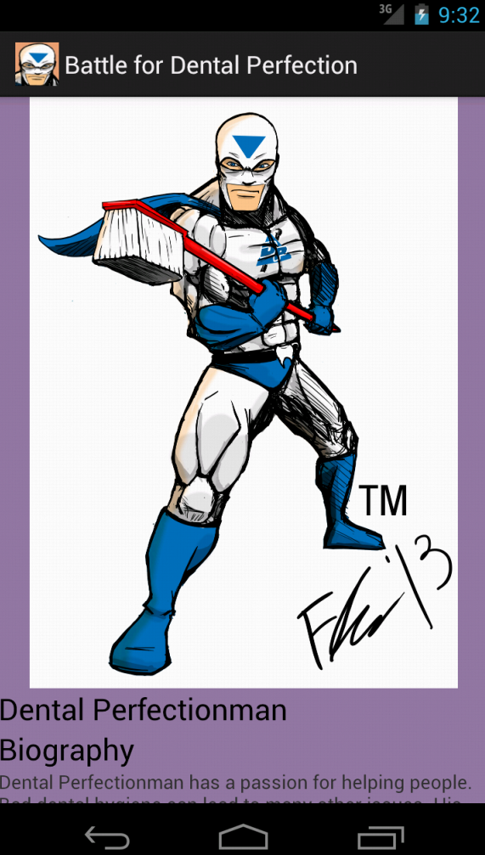

Opened biography part 1.

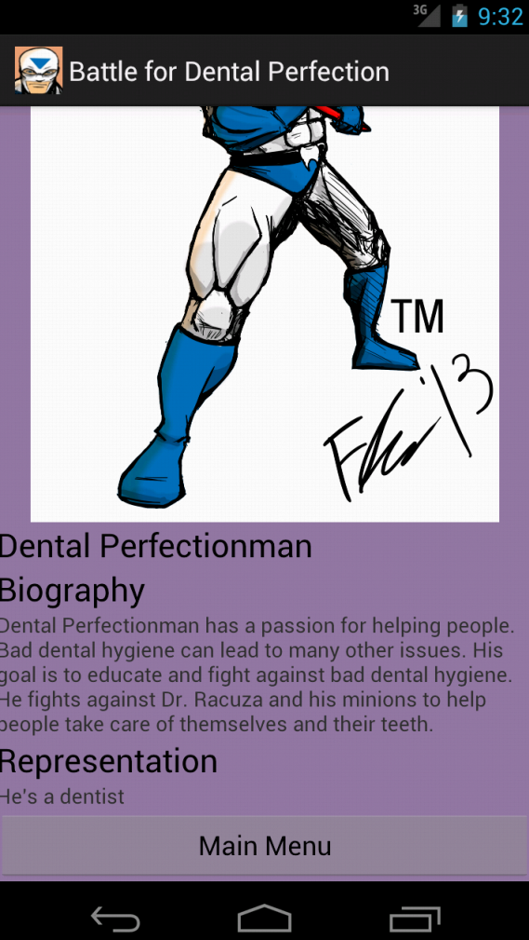

Open biography part 2.

Tapping on Main Menu takes you back to the biographies screen.

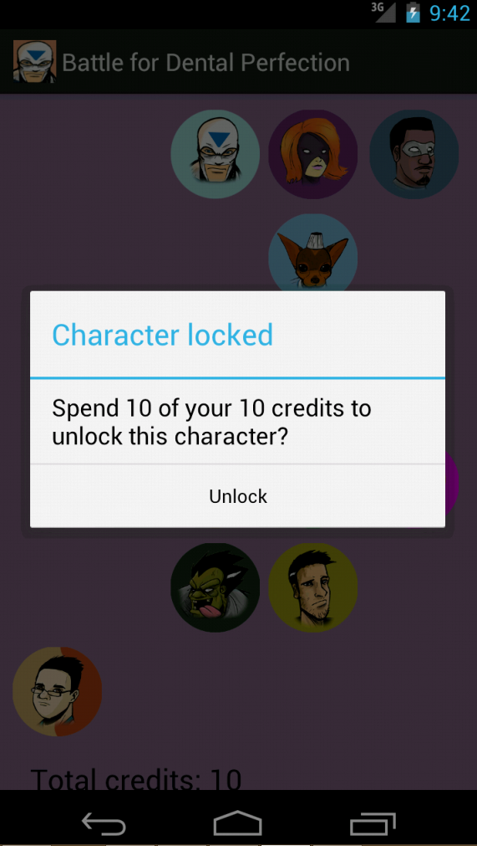

Dialog is shown confirming you wish to spend credits to unlock a new character when a locked character is selected.

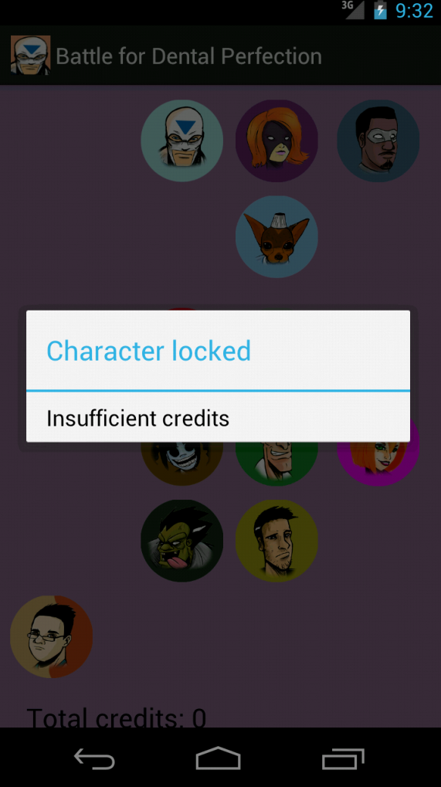

This dialog is shown when there are not enough credits to unlock a biography when a locked character is selected.

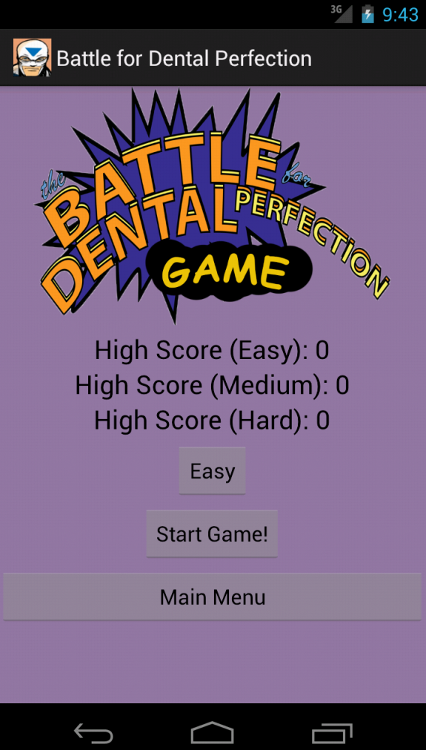

Main screen for game. From here the highscores for each difficulty is shown. By tapping the button labeled “Easy”, the difficulty will change. The difficulty determines the player’s starting HP value and the maximum HP they get back from dental product bonuses. Difficulty button changes as it is tapped. 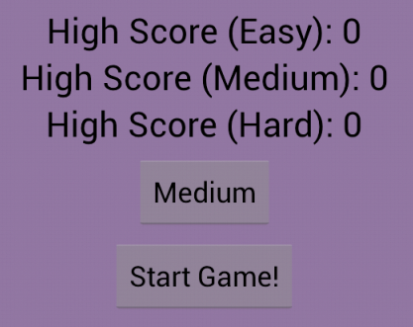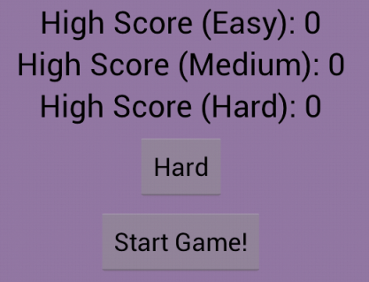

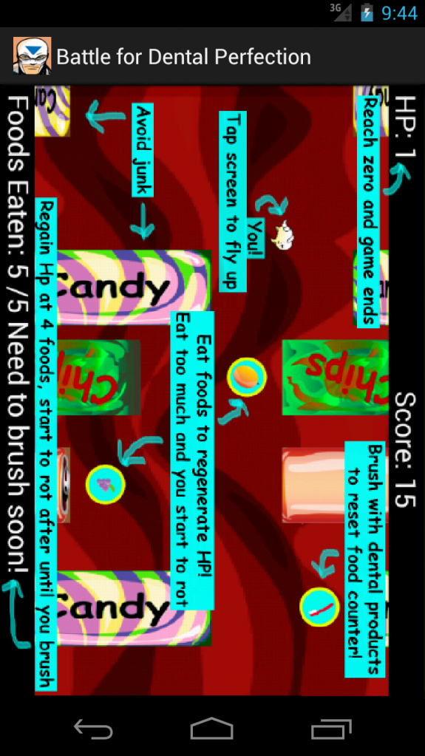

Tutorial screen that is displayed before the game begins. Game starts when player taps screen.

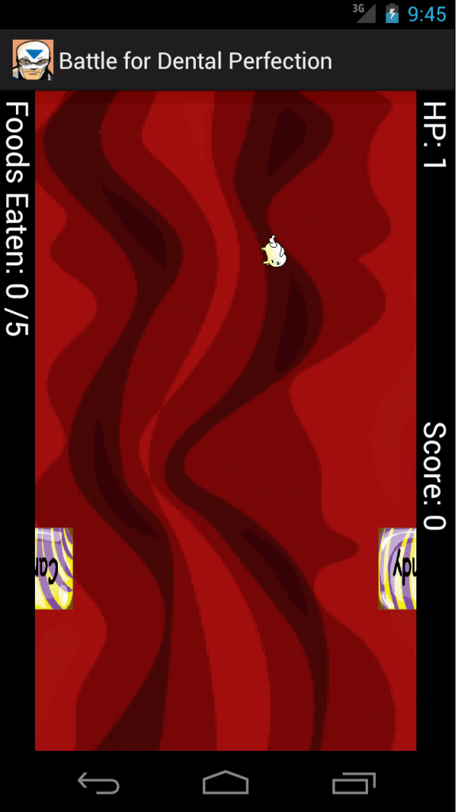

Start of the game. Hardly any obstacles present so player can get a feel of controls. Difficulty ramps up soon after.

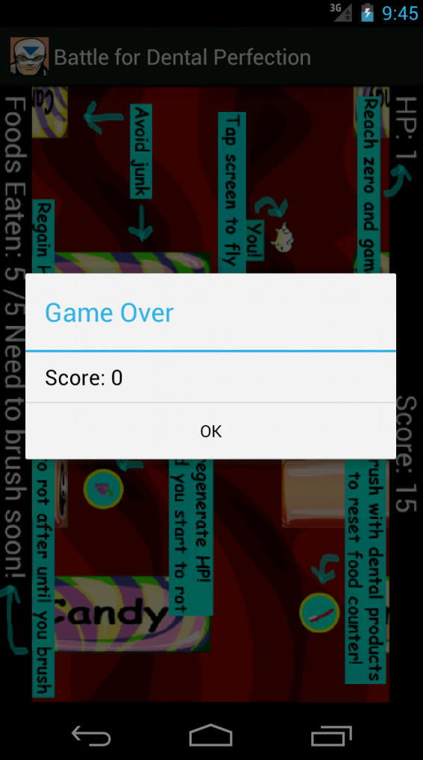

Game ends when player HP = 0 or player exits view of the screen.